UNITED STATES

SECURITIES AND EXCHANGE COMMISSION

Washington, D.C. 20549

SCHEDULE 14A

Proxy Statement Pursuant to Section 14(a) of the Securities

Exchange Act of 1934

Filed by Registrant Filed by a Party other than the Registrant
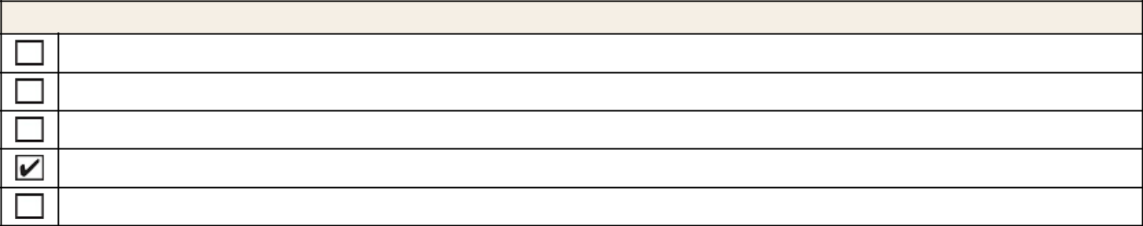

Check the appropriate box:

Preliminary Proxy Statement

Confidential, for Use of the Commission Only (as permitted by Rule 14a-6(e)(2))

Definitive Proxy Statement

Definitive Additional Materials

Soliciting Material under § 240.14a-12

DIAMONDBACK ENERGY, INC.


(Name of Registrant as Specified In Its Charter)

(Name of Person(s) Filing Proxy Statement, if other than the Registrant)
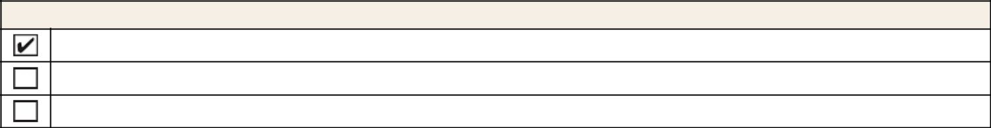

Payment of Filing Fee (Check the appropriate box):

No fee required

Fee paid previously with written preliminary materials

Fee computed on table in exhibit required by Item 25(b) per Exchange Act Rules 14a-6(i)(1) and 0-11



